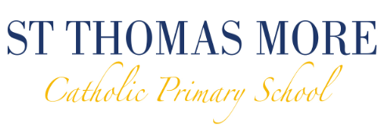
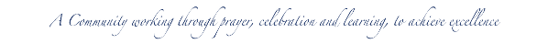
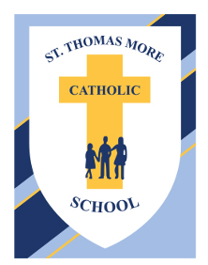

Prayer and Liturgy Policy

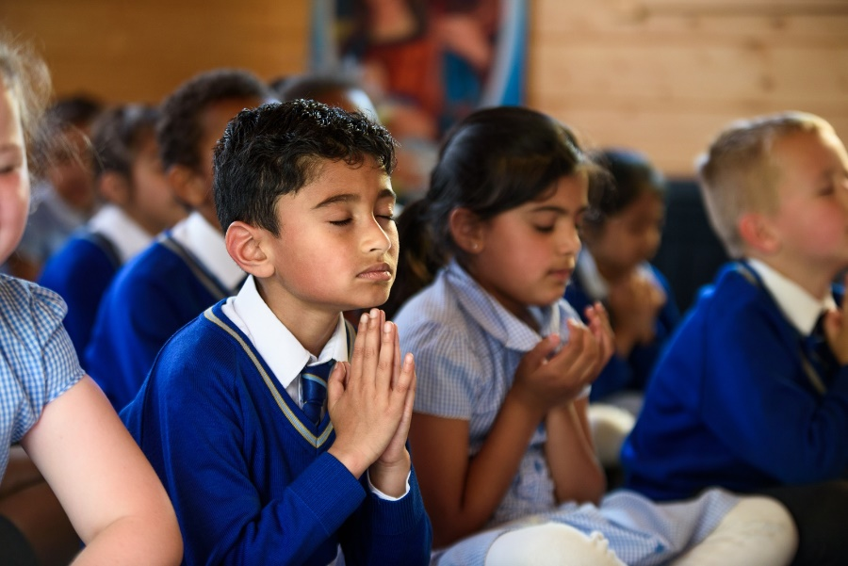

September 2025
Review date: September 2026

Prayer and Liturgy Policy
At St Thomas More prayer, celebration and worship are at the heart of school life.
Mission: A community working through prayer, celebration and learning, to achieve excellence.
Our Mission Statement is at the heart of our school ethos and permeates every aspect of school life.

Community

St Thomas More Catholic Primary School is a community, which works in partnership with parents to enable each child to become a valued member of society. Our community, through its thoughts and actions, promotes good citizenship.

Prayer

We are a worshipping community, which respects other faiths and cultures and comes together in unity with them to praise God.

Celebration

We celebrate the achievements of our community through rewards, praise and encouragement and by sharing our successes with the wider community.

Learning

By planning and working as a team, we, the teachers, governors and parents, ensure our children work to their full potential to achieve consistently high standards, enjoy their learning and make progress.

Excellence

We strive to achieve excellence in everything and always try to be the very best version of ourselves at all times.

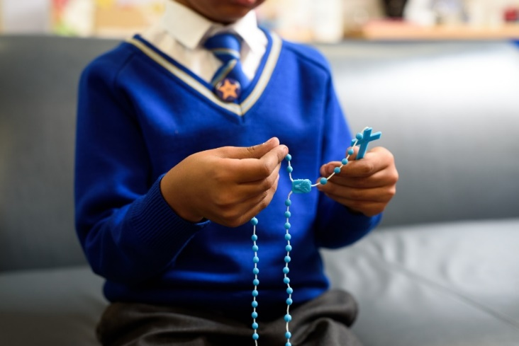

The Place of Prayer and Liturgy in the Life of the school
Prayer and liturgy is an integral part of our school life and central to the Catholic tradition.
It takes into account the religious and educational needs of all who share in it:
- Those who form part of the worshipping community in church;
- Those for whom school may be their first and only experience of church;
- Those from other Christian traditions – or none;
- Those from other faith backgrounds.

Aims
Prayer and liturgy in St Thomas More School aims to provide opportunities for all pupils and staff:
- To contemplate the mystery of God
- To reflect on spiritual and moral issues
- To explore personal beliefs
- To respond to and to celebrate life
- To experience a sense of belonging and to develop community spirit
- To develop a common ethos and shared values
- To enrich religious experience
- To grow in liturgical understanding and development
- To pray using prayers which are part of the Catholic tradition
- To reinforce positive attitudes
- To participate fully
- To take time out ‘to wonder at’, ‘to come to terms with’ and ‘to give worth to.’

Principles
All acts of prayer in St Thomas More School will:
• Give glory and honour to God;
• Be a quality activity, fundamental to the life of the school and its Catholic character;
• Enable pupils to develop skills so that they can prepare, organise and lead prayer times;
• Give pupils positive liturgical experiences, appropriate to their age, aptitude and family backgrounds in order to prepare them for the liturgical

Statement of Requirement
The law requires all maintained Catholic schools to provide an act of daily collective worship (prayer and liturgy) for all pupils, including those in the sixth form (Section 70, 1988 Education Act) that is in accordance with the rites, practices, disciplines, and liturgical norms of the Catholic Church (School Standards and Framework Act 1998, schedule 20; Instrument of Government, clause 2).

Academies in England are required by their funding agreement and Articles of Association to comply with similar requirements (The Mainstream Academy and Free School: Supplemental Funding Agreement, December 2020; Model Articles for Catholic Academies, February 2019).
The law requires all maintained schools to recognise and respect that parents have the legal right to withdraw their children up to the age of 16 from prayer and liturgy (School Standards and Framework Act 1998, s.71(1A)).
The school’s provision for prayer and liturgy will fulfil pupils’ entitlement to experience the range of liturgical treasures of the Church, including a shared repertoire of prayers and liturgical music with which pupils in the school will be familiar.
Prayer and liturgy are not designated curriculum time. In the context of the Catholic school, this means that times of prayer and liturgy are not considered to be part of the allocation of curriculum time for Religious Education.

Responsibility
  - Governance
The governors, as guardians of the Catholic school’s life and mission, have a responsibility to ensure that:
- prayer and liturgy are central to the Catholic life of the school and therefore are in line with the guidance set out by the Prayer and Liturgy Directory
- there is a named person(s) who is responsible for prayer and liturgy in the school (the Prayer and Liturgy Coordinator). Patrick O’Shea
- the prayer and liturgy policy is updated regularly and shared with all stakeholders
- there is a budget for prayer and liturgy that reflects its centrality to the life of a Catholic school.

Headteacher

The headteacher, as the spiritual leader of the school as a Catholic community, ensures that:
- prayer and liturgy are central to the Catholic life of the school and therefore are in line with the guidance set out by the Prayer and Liturgy Directory
- they work in partnership with the leader(s) for prayer and liturgy
- those responsible for prayer and liturgy in the school have been given appropriate training and formation to ensure that all guidance is followed and adhered to
- there are suitable resources for prayer and liturgy in the school.

Prayer and Liturgy Coordinator
Those responsible for prayer and liturgy ensure that:
- prayer and liturgy are central to the Catholic life of the school and therefore are in line with the guidance set out by the Prayer and Liturgy Directory
- there is an Annual Plan of Provision for prayer and liturgy across the school year which identifies liturgical seasons and key celebrations, as well as opportunities for the celebration of the Sacraments.
- there is daily planned prayer for all pupils, appropriate to age and ability, as outlined in the Prayer and Liturgy Directory
- pupils are supported in their liturgical formation to take an active role in the planning, preparation, and delivery of prayer and liturgy according to their age and capacity, and in a manner which facilitates their progressive participation
- resources to support the planning of prayer and liturgy are appropriate and readily available to staff and pupils
- induction on prayer and liturgy takes place for new members of staff as required
- staff have access to effective training and formation opportunities
- monitoring and evaluation of prayer and liturgy take place regularly and feed back into planning for future liturgies
- monitoring of prayer and liturgy is reported to the headteacher and governing body to support whole-school development and the Catholic life of the school
- there is collaboration with local clergy and parishes
- liaison with the Diocesan Advisory Service and others is maintained to ensure they keep updated with best practice.

Overview of Prayer and Liturgy Provision

When Prayer & Liturgy Takes Place
Prayer and liturgy is planned following a structure with reference to the Church's seasons, feast days, the curriculum and significant dates e.g. CAFOD Family Fast Day.
Parish and parents are invited to participate in some celebrations.
A variety of prayer styles will be used appropriate to the age of the children and the occasion.

The Pattern of Prayer & Liturgy
At St Thomas More, prayer is understood as communicating with God and daily opportunities are provided for both formal and informal prayers, both individually and collectively.

- Formal Prayers are taught throughout the school and progress in complexity of language and conceptual understanding. All children are encouraged to learn, unprompted, the prayers which are considered suitable for their age.
- Informal Prayer, both silent and open, is encouraged throughout the school. Opportunities are given during most prayer sessions for an individual response, privately or publicly, and all respect this practice.
- Individual Prayer is encouraged through the provision of a spiritual focus in each classroom and the two Reflection areas, one in the school entrance and one in the Spiritual Garden. These are available to staff and children, during break and lunchtimes and allows for private or shared reflection. Pupils each have their own Prayer Journal that travels with them throughout their time at school. Within their Prayer Journal there are opportunities for Spiritual Journaling and personal responses to Scripture.
- Collective Prayer encompasses both formal and informal praying and usually includes sung prayer in the form of a hymn or psalm appropriate to the liturgical year. This may include:

- Daily class prayers at the beginning and end of each day. – children are often encouraged to offer their prayers out loud or are given time for silent reflection
- There are Thanksgiving prayers before lunch each day.
- During assemblies and at the end of the school day children are encouraged to examine their conscience and say sorry for things they have done wrong.
- Weekly Sung Worship links to the upcoming Mass/Service or Feast day celebration, or to extend pupils’ experience of sung responses.
- Each week a whole school Gospel assembly is led by a member of SLT. The theme is usually based on the Sunday Gospel and is attended by all staff and visitors in the school.
- Pupils are encouraged to say the Rosary during May.
- Staff Meetings and Parent Meetings always begin with prayer.

Mass & Reconciliation
The Eucharist celebration is the prime acknowledgement by the school of its membership of the Church and is therefore its central worship. It is essential that the children are included in the celebration in a meaningful way and begin to develop an understanding of the Mass.

• Regular Masses in school, prepared by Junior Chaplains
• Adult Chaplains prepare children to read at Mass, so that pupils can fulfil their baptismal promise to be ‘Servant, priest & King’.
• All EYFS, KS1 pupils and those pupils in KS2 who have not celebrated their First Holy Communion invited to receive a Blessing.
• The Mass dates and times are included on the school website and the weekly school newsletter so all parents are invited to attend.

In the season of Lent all pupils take part in a Stations of the Cross service within school, led by the Adult Chaplains. Children in KS2 are given the opportunity to go to confession during Lent and Advent within school, following a Reconciliation reflection.

Special Liturgies

From time to time, the school, Year groups or classes may prepare and celebrate a Liturgy.

Resourcing
Prayer and liturgy are central to the school’s understanding of itself as a Catholic school, and this is reflected in the annual RE budget allocation and available resources, including staff time, chaplaincy provision, and dedicated spaces for prayer and liturgy. The annual budget for RE will at least match the annual budget allocation for English and Maths. The Catholic character of the school is reflected in religious artefacts and images on display throughout the building. Dedicated spaces for prayer and liturgy will be furnished and maintained as such, and updated to reflect the Church’s liturgical season. Staff training and formation costs will be funded from the overall RE budget to ensure that all staff are able to fulfil their responsibility to contribute to the prayer and liturgical life of the school.

Training and Formation
All new staff will be supported during induction and beyond, so that they fully understand the responsibility they carry within their individual role for leading prayer and liturgy in the school. In the first instance, this will be done as part of the St Thomas More school new staff induction process. Any individual training needs will be identified and addressed through training and formation. There will also be the opportunity for whole-staff professional development at least once a year, so that all staff understand the importance of prayer and liturgy and relevant staff are well supported to lead as required. CPD opportunities are detailed on the school CPD schedule for the year. l. School staff will be given opportunities for training and formation through the Trust, the Diocese and beyond, for example completing the DCCRS or CCRS.

Monitoring and Evaluation
Monitoring and evaluation of the quality and impact of prayer and liturgy will take place regularly, and at least annually, and involve all key stakeholders: pupils, parents, staff, clergy, and governors. Areas for development will be identified on monitoring Feedback Forms, RE Action Plans and the School Improvement and Development Plan and issues raised will be actioned and evidenced as appropriate.

Review
The policy will be reviewed every year as part of the regular cycle of policy review conducted by the governors.

This prayer and liturgy policy has been written by Leanne Phillips (RE Lead) and Thomas Claxton (Headteacher)

